***Florida International University***

***School of Computing and Information Sciences***

Software Engineering Focus

Feature Document

User Story #825

**Team Member:**

April Perry

**Product Owner(s)​**:

Gummi Traustason

**Mentor(s)​**:

Masoud Sadjadi

**Instructor​**: Masoud Sadjadi

**USER STORY​** - **“App - History Page option”**

* As a PLAYER, I want to have an option on the main dashboard to view a separate page devoted to my History, so that I can review such statistics.

Acceptance Criteria

* Player is logged in
* Player has completed games
* Player has saved results

**Use Case #825...​ “App - History Page option”**

**Use Case Diagram**

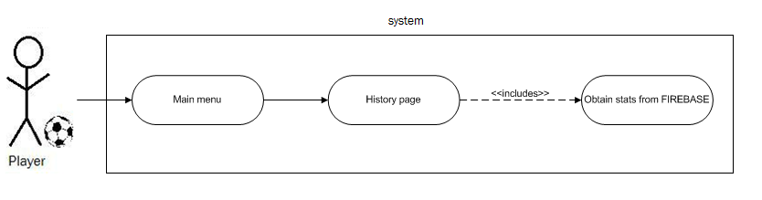

**Sequence Diagram**

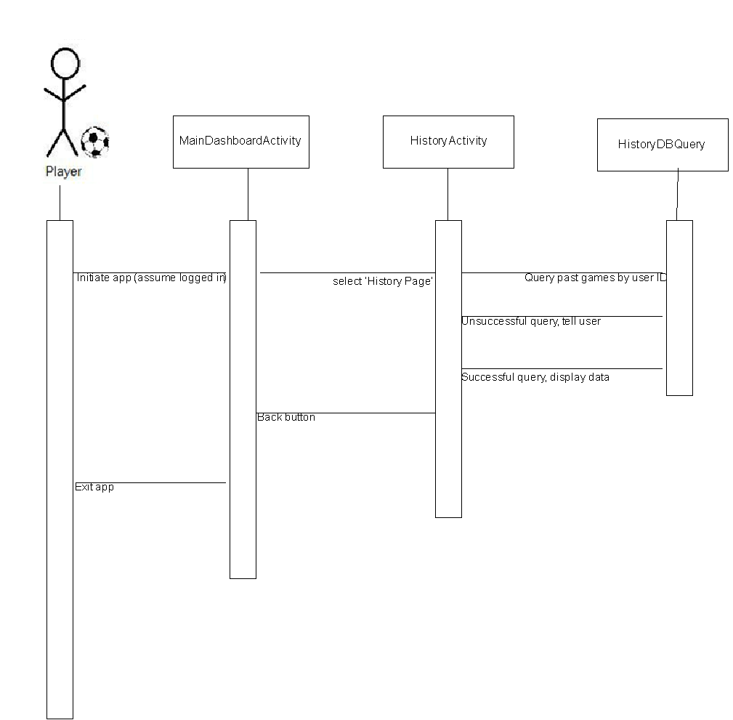

**Class Diagram**

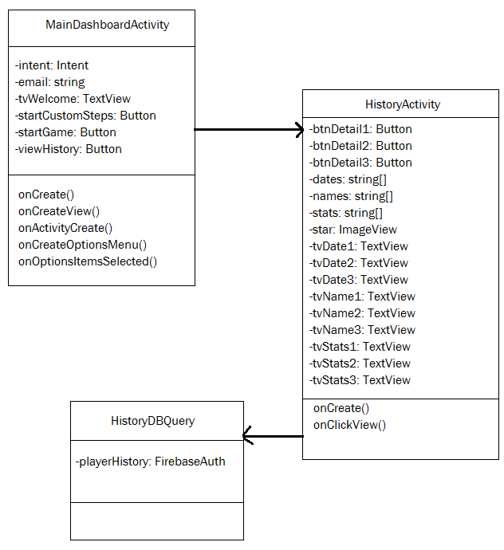

**Unit Test**

* Test History button on main dashboard page
* Test functionality and layout of history page
* Test Details buttons (each of them) on history page
* Test functionality and layout of details page

**Integration Test**

- Login to app and main dashboard

- Make sure other buttons still work

- Make sure that the original layout was not altered

- Make sure new button works

- Make sure new layout flows well with rest of app

**Visual Diagram**

